**Trabalho Neo4J**

**334409 - Charles Guimarães Cavalcante**

**Carregar o Banco com os Scripts:**

**1-Load_Matches_neo4j.txt**

Added 1075 labels, created 1075 nodes, set 5726 properties, created 5443 relationships, completed after 2177 ms.

**2-Load_Squads_neo4j.txt**

Added 7213 labels, created 7213 nodes, set 14035 properties, created 9385 relationships, completed after 28782 ms.

**3-Load_LineUps_neo4j.txt**

Created 33937 nodes, created 67874 relationships, completed after 35696 ms.

**4-Load_Events_neo4j.txt**

Added 150 labels, created 204 nodes, set 408 properties, created 204 relationships, completed after 2359 ms.

**Elaborar consultas para:**

**Estádios com mais gols**

**Query**

MATCH (p:Partida)-[:DISPUTADA_NO]->(e:Estadio)

RETURN e.nome as estadio,

SUM(toInteger(p.placar_casa)) +

SUM(toInteger(p.placar_visitante)) AS gols

ORDER BY gols DESC

**Resultado**   
  
[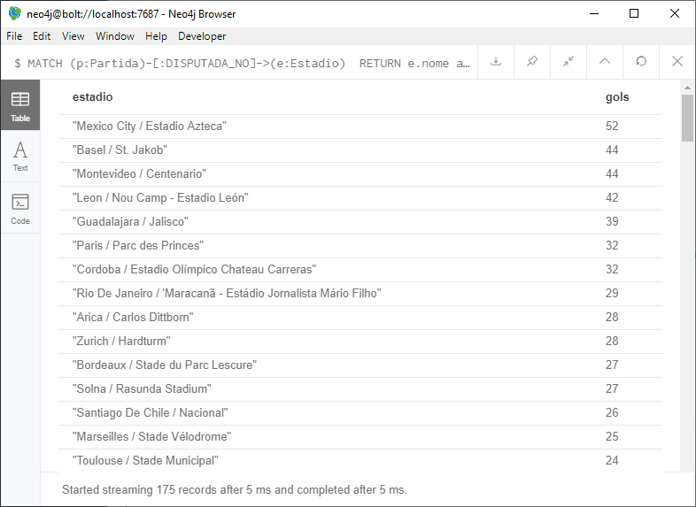](https://github.com/charlesartbr/fiap-mba-big-data-data-science/blob/master/Banco%20de%20Dados%20NoSQL/Aula%205%20-%20Neo4J/aula5-trabalho-query1.png)

**Jogadores que participaram em mais do que uma copa**

**Query**

MATCH (j:Jogador)-[:JOGOU_POR]->(s:Selecao)

WITH j.nome AS nome, COUNT(*) AS convocacoes

WHERE convocacoes > 1

RETURN nome, convocacoes

ORDER BY convocacoes DESC

**Resultado**   
  
[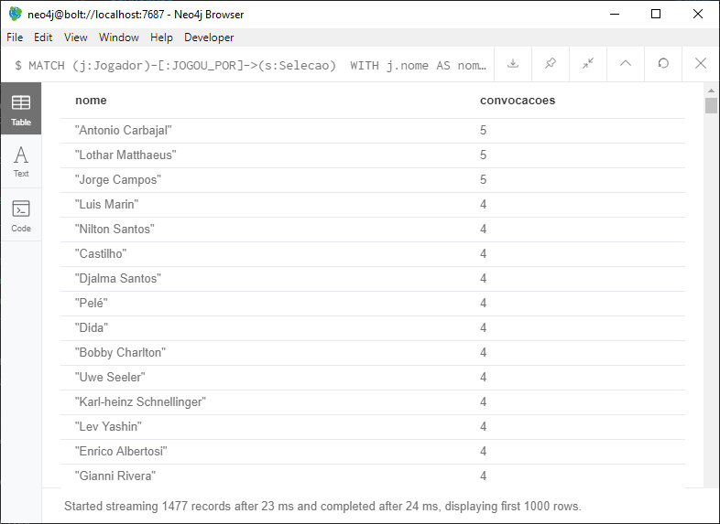](https://github.com/charlesartbr/fiap-mba-big-data-data-science/blob/master/Banco%20de%20Dados%20NoSQL/Aula%205%20-%20Neo4J/aula5-trabalho-query2.png)